Polymorphism

📌 Definition:
# Source: AI Source: Provided by: [Data Path: Persons Table -> ID Column: 1, Name_En Column: Motasem Essam] -> From: [ChatGPT] on [12/9/2025]
Polymorphism is an OOP principle where a single method or action can behave in different ways depending on the context.

🧠 Simple idea:
# Source: AI Source: Provided by: [Data Path: Persons Table -> ID Column: 1, Name_En Column: Motasem Essam] -> From: [ChatGPT] on [12/9/2025]
Polymorphism = “One interface, many forms” 🎭

🔍 Key characteristics:
# Source: AI Source: Provided by: [Data Path: Persons Table -> ID Column: 1, Name_En Column: Motasem Essam] -> From: [ChatGPT] on [12/9/2025]
- 🔄 Same method name, different behavior
- 🧩 Works with methods and objects
- ⚙️ Increases flexibility and reusability
- 🧠 Helps write more generic code

📌 Types of Polymorphism:
# Source: AI Source: Provided by: [Data Path: Persons Table -> ID Column: 1, Name_En Column: Motasem Essam] -> From: [ChatGPT] on [12/9/2025]
1️⃣ Compile-time Polymorphism (Method Overloading)
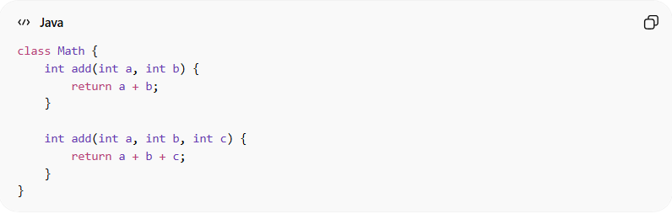
- Same method name, different parameters
class Math {
int add(int a, int b) {
return a + b;
}

int add(int a, int b, int c) {
return a + b + c;
}
}

2️⃣ Run-time Polymorphism (Method Overriding)
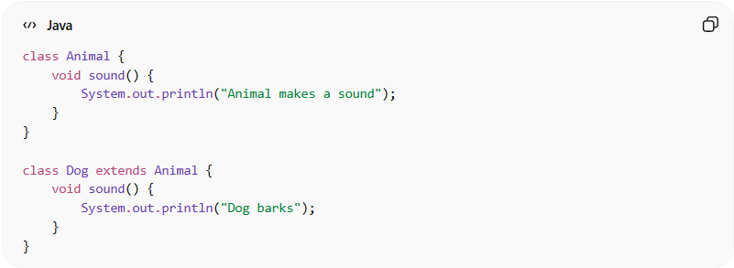
- Child class overrides parent method
class Animal {
void sound() {
System.out.println("Animal makes a sound");
}
}

class Dog extends Animal {
void sound() {
System.out.println("Dog barks");
}
}

Usage:
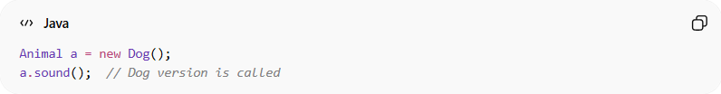
Animal a = new Dog();
a.sound(); // Dog version is called
👉 Same method (sound()), different behavior

🆚 Polymorphism in Action:
# Source: AI Source: Provided by: [Data Path: Persons Table -> ID Column: 1, Name_En Column: Motasem Essam] -> From: [ChatGPT] on [12/9/2025]
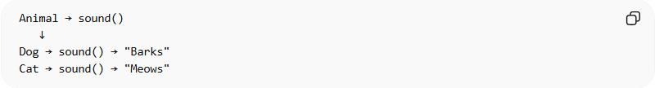
Animal → sound()
↓
Dog → sound() → "Barks"
Cat → sound() → "Meows"

⚙️ Real-world example:
# Source: AI Source: Provided by: [Data Path: Persons Table -> ID Column: 1, Name_En Column: Motasem Essam] -> From: [ChatGPT] on [12/9/2025]
- 🎮 Button click in apps can trigger different actions
- 🖱️ Same action (click) → different results

🎯 Why polymorphism is important:
# Source: AI Source: Provided by: [Data Path: Persons Table -> ID Column: 1, Name_En Column: Motasem Essam] -> From: [ChatGPT] on [12/9/2025]
- 🔄 Improves flexibility
- 🧩 Makes code reusable
- 🧠 Reduces complexity
- ⚙️ Supports dynamic behavior

🎯 Summary:
# Source: AI Source: Provided by: [Data Path: Persons Table -> ID Column: 1, Name_En Column: Motasem Essam] -> From: [ChatGPT] on [12/9/2025]
Polymorphism allows the same method or action to behave differently based on the object or context, making programs more flexible and powerful.

